Executive Summary

Business Goal

The business goal is to determine optimal locations for a startup craft brewery within the Denver Metro area, considering factors such as low competition from existing breweries and a population capable of sustaining regular customers.

Approach

1. Data Collection
- Population densities and demographics were analyzed using the latest US Census Bureau data.
- The Foursquare API, Google, and coloradobrewerylist.com were used to identify established craft breweries in the region.

2. Hypothesis
- Craft beer consumption in the Denver-Lakewood-Aurora Metropolitan Statistical Area is influenced by demographic factors, including existing breweries, education, household income, age distribution, gender composition, ethnic diversity, and specific occupational profiles.

3. Geographic Boundaries
- US Census Bureau shapefiles for the Denver Metro area were used to define geographic boundaries.
- Focus on the Denver-Lakewood-Aurora MSA and adjacent areas, excluding Boulder.

4-7. Analysis Methods
- Geospatial Analysis: Utilized Geopandas for spatial joins and consolidated geometry.
- Demographic Analysis: Employed American Community Survey (ACS) 2021 data for Census Place-level analysis.
- Craft Beer Drinker Demographics: Considered key demographics based on craft beer trade associations publications.
- Occupational Analysis: Evaluated occupations with higher alcohol consumption rates.

8. Conclusion
- Synthesized findings to recommend optimal locations for the craft brewery based on the desired demographic profile and minimal competition from existing breweries.

Brewery Data Collection

- Breweries were sourced from FourSquare, Google, and coloradobrewerylist.com within the Denver-Lakewood-Aurora Metropolitan Statistical Area (MSA).
- Coloradobrewerylist.com was identified as the most accurate and comprehensive source for brewery information in the region.

Brewery Comparison

- Google's Places API includes non-brewery establishments.
- Foursquare lacks a significant number of breweries within the Denver MSA.
- Coloradobrewerylist.com provides a comprehensive list, excluding some chain establishment locations.

Geospatial Demographic Analysis

- Choropleth plots using the Folium library were created to analyze demographics.
- Median household income was identified as an important factor.
- Covariance and multicollinearity were considered.

Variables Exploration

- Examination of mean and median household income revealed outliers and potential wealth disparities.
- Population density varied, with larger cities having lower densities.
- PCA was used for dimensionality reduction and understanding relationships within the data.

PCA Overview

- Two DataFrame orientations were considered: Places and Variables.
- Scree plot and PC1 vs PC2 plots provided insights into data variation.
- PC1 loadings identified influential features contributing to data patterns.

Census Places - K-Means Clustering

- KMeans clustering with a silhouette score of 0.76 suggested 4 optimal clusters.
- Denver and Aurora formed distinct clusters, while Lakewood did not.
- Clusters were stratified by total population.

Census Places - Agglomerative Clustering

- Agglomerative clustering with five clusters identified natural density structures.
- Denver, Aurora, and Lakewood naturally formed their own clusters.

Census Places - DBSCAN Clustering

- DBSCAN with 'euclidean' metric and a silhouette score of 0.70 identified 5 optimal clusters.
- Clustering aligned with agglomerative clustering, providing insights into brewery distribution.

Brewery Locations - DBSCAN Clustering

- DBSCAN with 'haversine' metric identified 31 optimal clusters for 181 breweries.
- Despite a low silhouette score, geospatial plots revealed distinct brewery clusters.
- Notable clusters included the central urban core encompassing downtown Denver, Denver International Airport, Aurora, Golden and various suburban areas.

Conclusions

- Unexpectedly, total population emerged as a comprehensive determinant of demographic clustering.
- Clustering algorithms confirmed the interdependence of demographic variables on total population.
- Multiple clustering methods provided a comprehensive understanding of the data's structure.
- Denver, Aurora, and Lakewood consistently stood out, reflecting their unique characteristics.
- A higher density of breweries are found in downtown Denver, Arvada, Centennial, Highlands Ranch and Golden.
- There are a lower concentration of breweries in Thornton, Lakewood, and Westminster but greater populations capable of supporting craft brewery patronage
- Summaries found within Jupter Notebooks emphasize the role of population in understanding the Denver Metro area's brewery distribution.

Figures

Exploratory Data Analysis
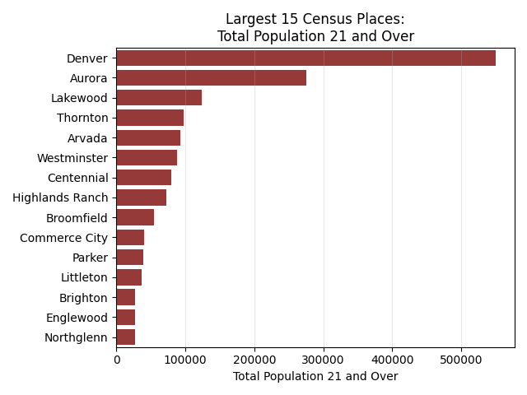

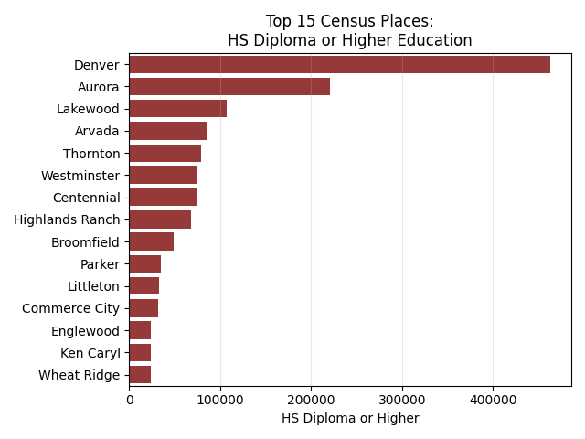

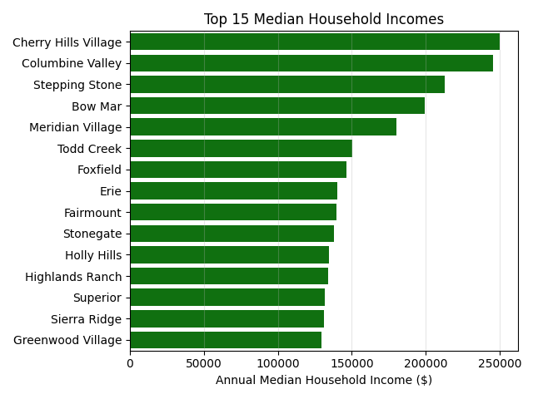

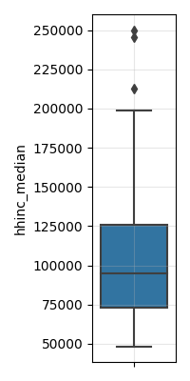
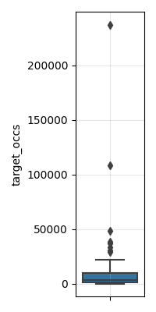
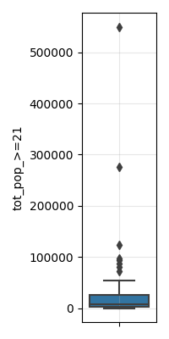

Target Occupations: target_occs

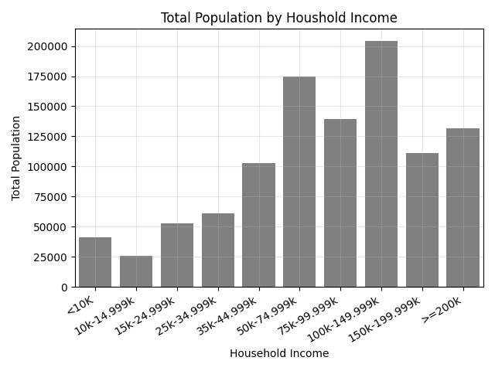
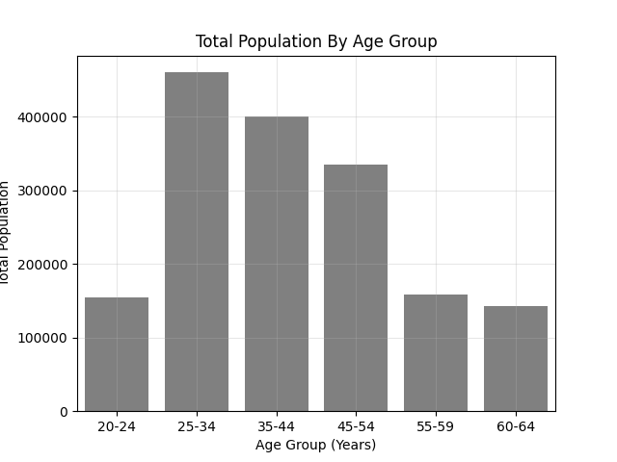

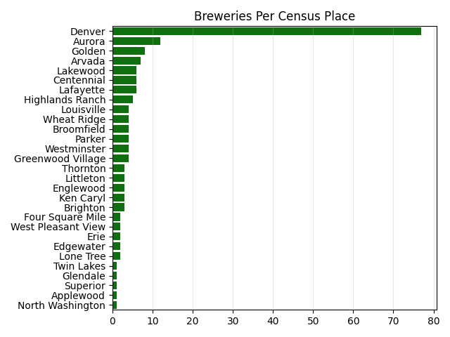
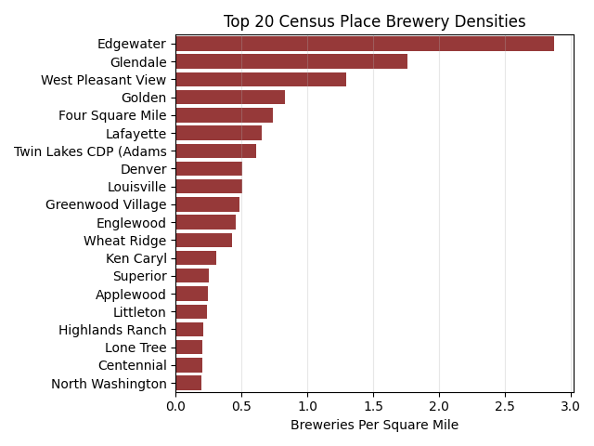

Models

Kmeans
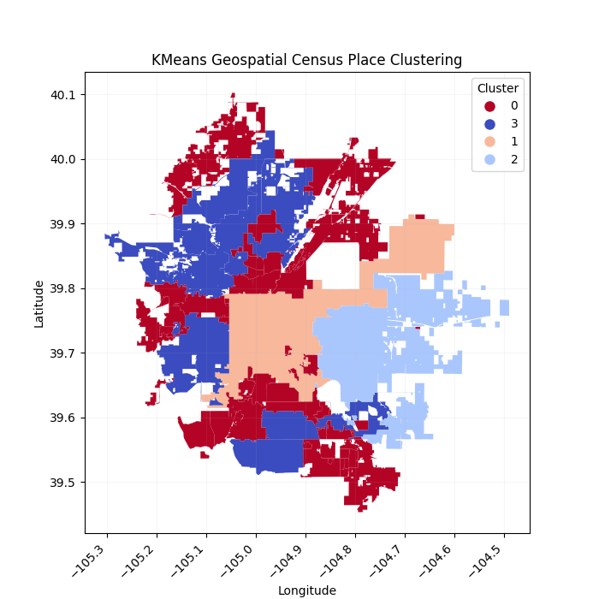

Agglomerative-Hierarchical
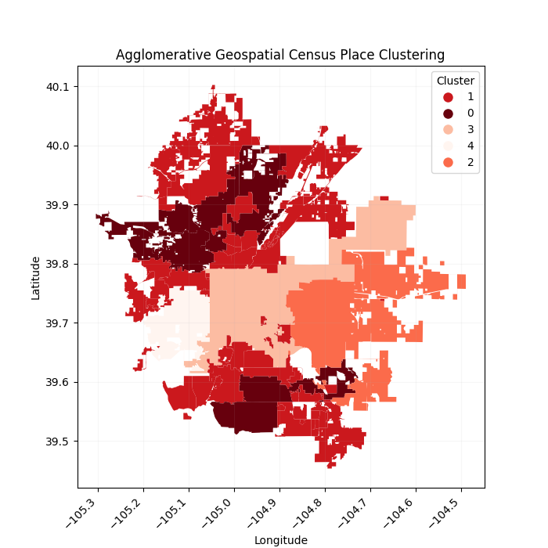

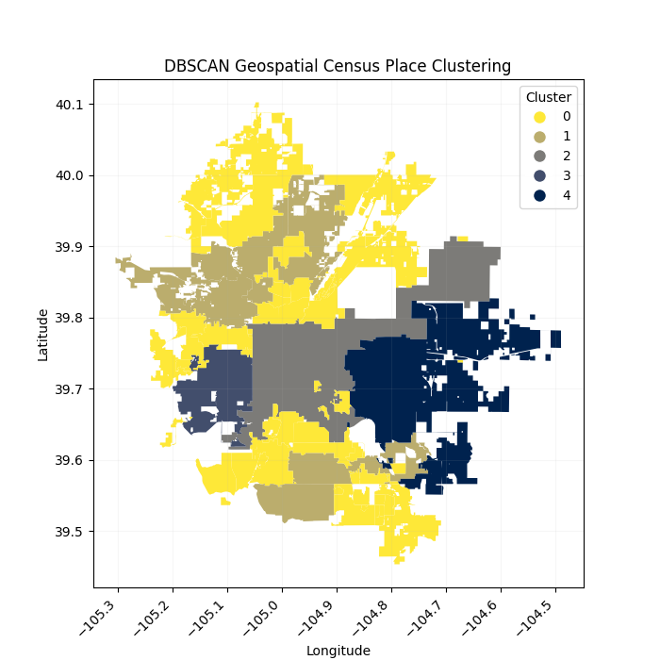
DBSCAN

Brewery Clustering via DBSCAN

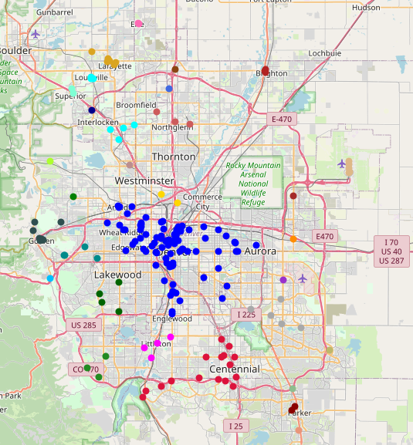
* All model Figures are available as interactive plots which can be opened in a web browser

